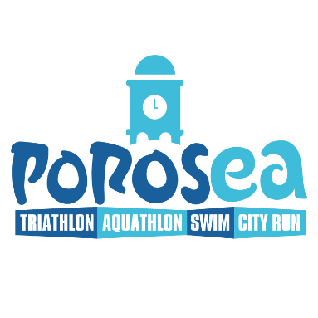
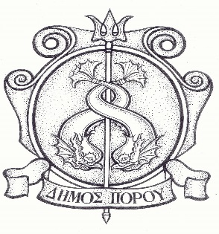
Poros, 12.4.2022

Announcement

Registration of Poros and Trizinia-Methana citizens for POROSEA 2022

Dear citizens of Poros and Trizinia-Methana,
We would like to inform you that for your participation in the multisport event POROSEA 2022 on May 28-29, the Municipality of Poros has secured a 40% discount on the event prices. The discount is valid from 15-04-2022 to 20-05-2022 and there will be no extension. Registrations will be made online at https://why-n.gr/event/porosea-2022/. To obtain the relevant voucher, please send an e-mail to contact@why-n.gr with the subject DIMOTIS.

Documents required for registration:
1. For triathlon, swimming and cycling races, a medical certificate dated no more than twelve (12) months from the date of the race, or a team card (of the current year) is required. For running races, no documentation is required.
2. Solemn declaration of adults (also issued by the Mayor's Office).
3. Solemn declaration of the parent or the legal guardian in case of participation of minors (also issued by the Mayor's Office).
4. Enter personal e-mail address to confirm registration.
5. Copy of the municipal register or certificate of permanent residence (only for citizens/permanent residents of the Municipality of Troizinias-Methana).

